**Practical 3: Types of Recording:.**

**Aim : Add two Numbers**

**3.A. Automate any process using basic recording**

Step 1: Open UI path and create new project with appropriate name and choose language type VB.

Step 2: Open notepad

Step 3: Click on App/Web recorder

Step 4: Click on notepad. Select white area and type anything. And save process.

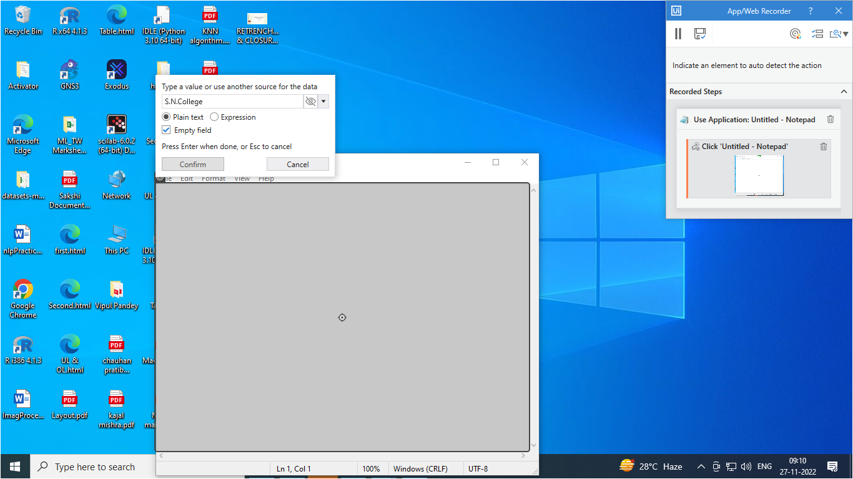

After saving it will create below structure automatically.

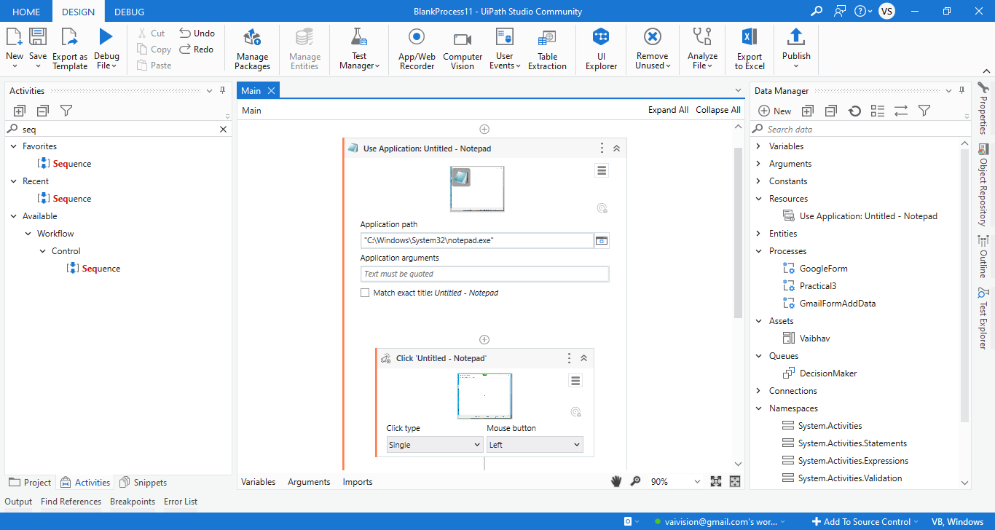

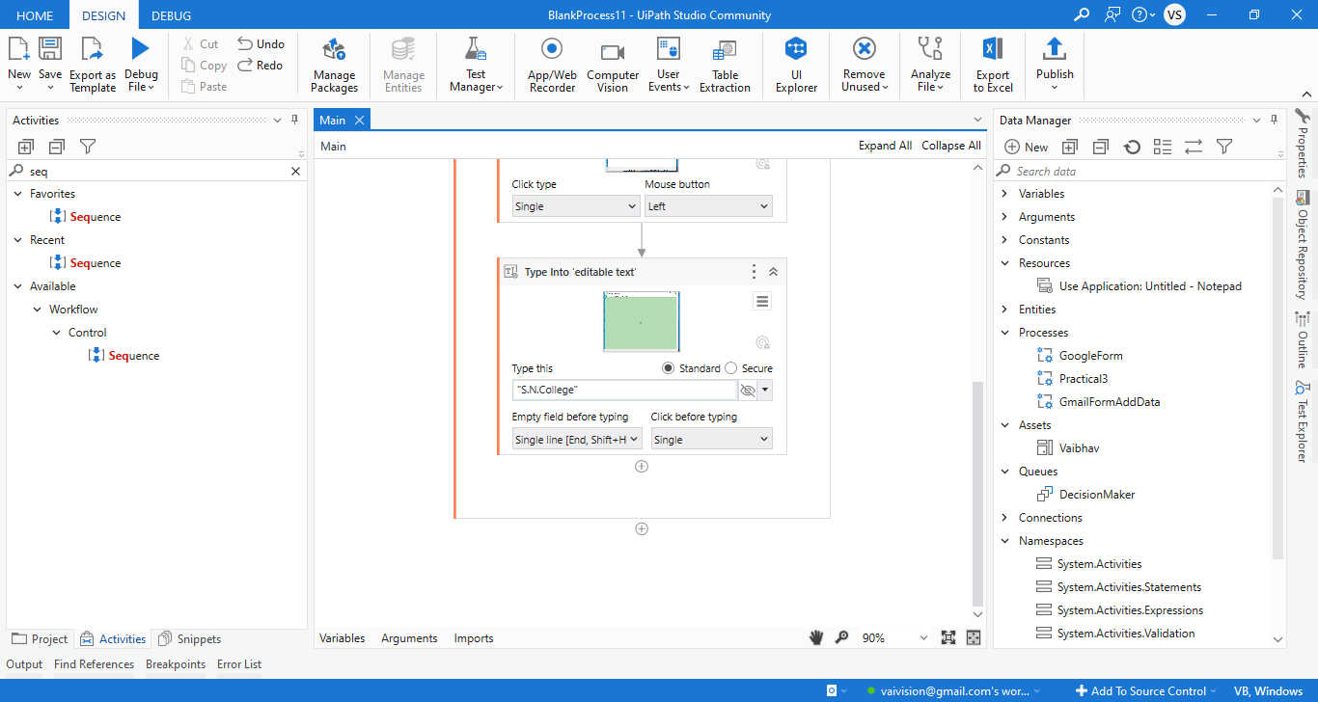

**O/P:**

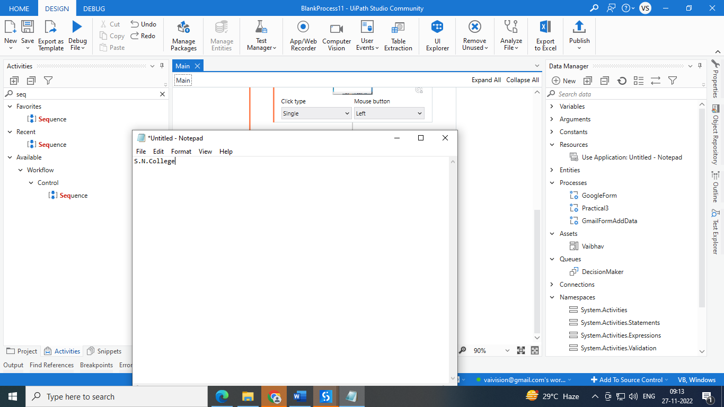

**B: Basic Recording using Notepad**

Step 1: Open UI path and create new project with appropriate name and choose language type VB.

Step 2: Click on App/Web recorder

Step 3: Click on search of windows. Select require application. Here I am selecting notepad.

Step 4: Then I select blank page of notepad and type into it.

Step 5: Then I click on File menu.

Step 6: Click on save and type file name.

Step 7: Click on save button.

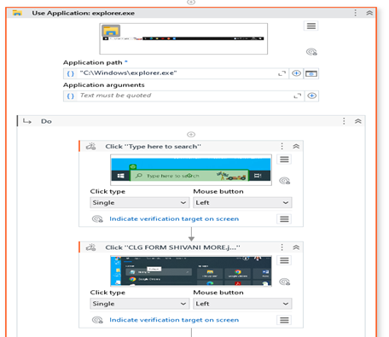

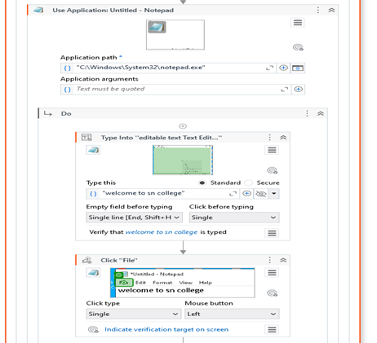

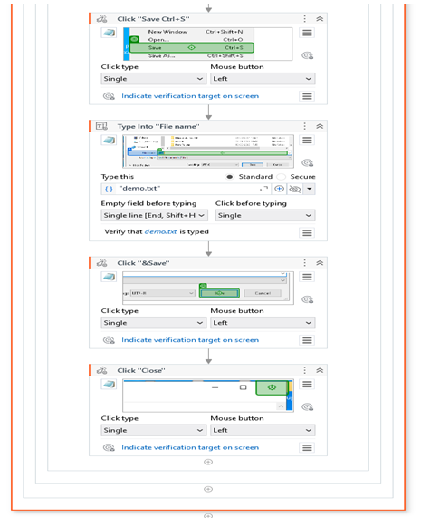

**O/P:**

**After running process Cursor will click on search of windows. Select require application. Here I am selecting notepad. Then I select blank page of notepad and type into it. Then I click on File menu. Click on save and type file name. Then click on save button.**

**3.C) Automate any process using desktop recording using Tool bar.**

Step 1: Open UI path and create new project with appropriate name and choose language type VB.

Step 2: Open notepad

Step 3: Click on App/Web recorder

Step 4: Click on notepad. Select white area and type anything. And save process.



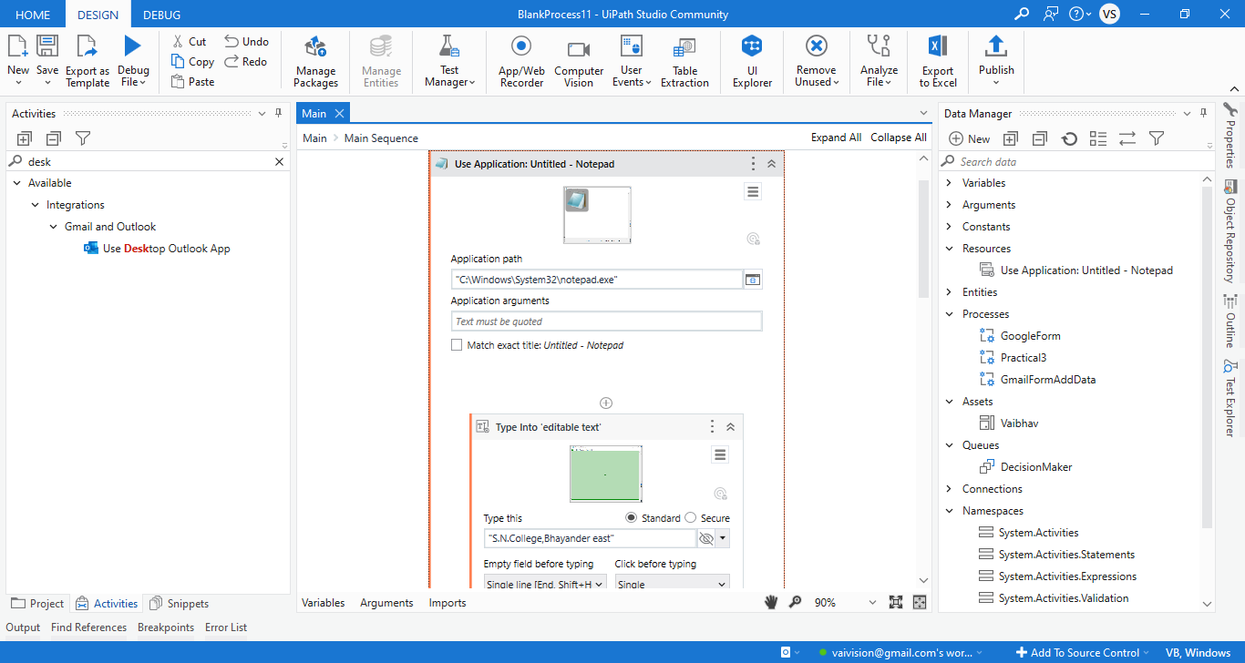

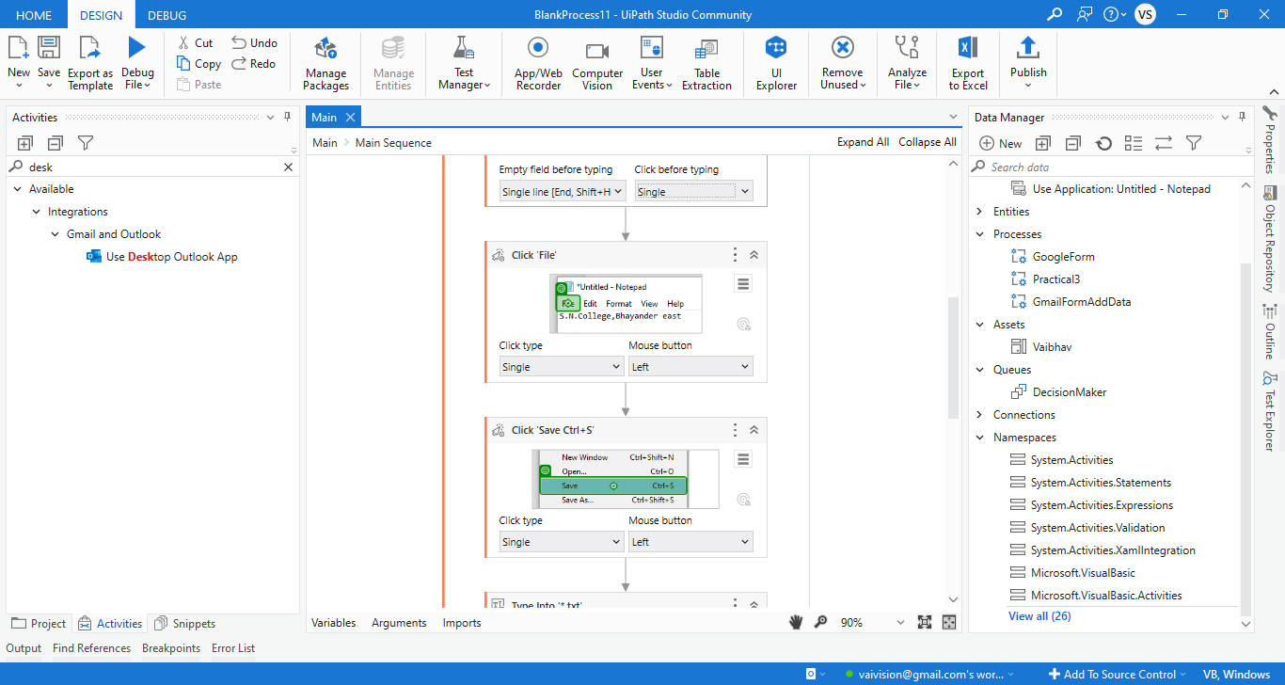

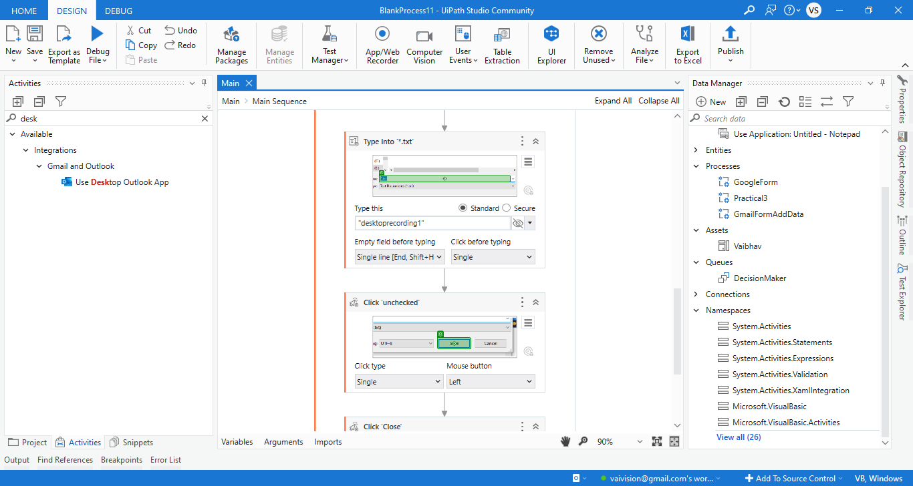

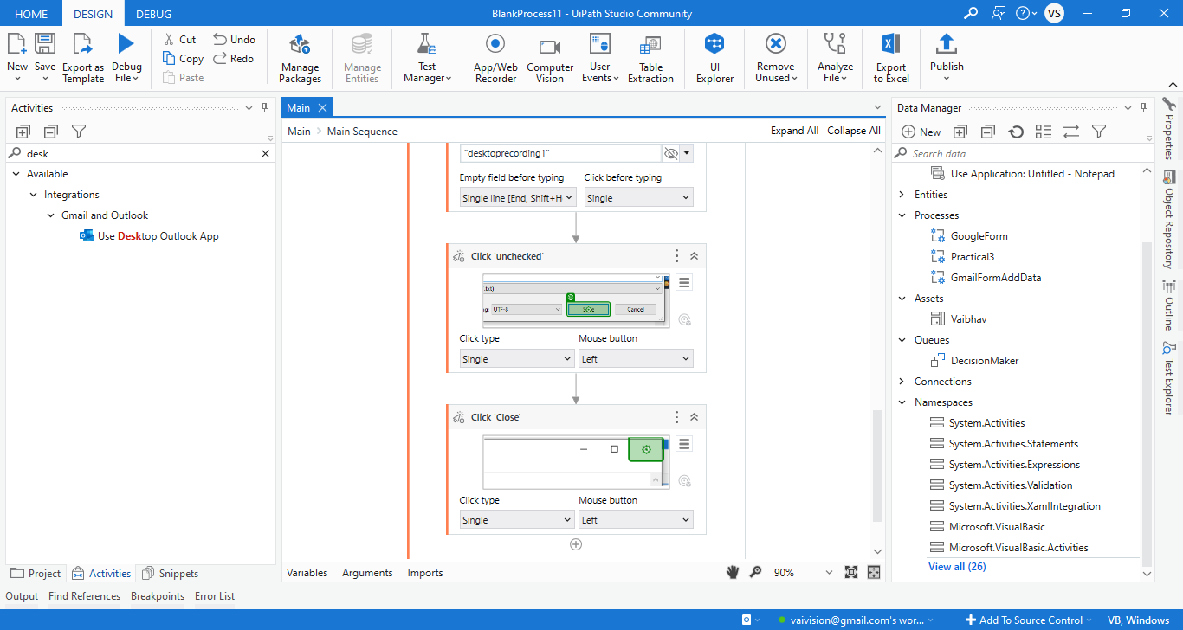

Step 5: Close the notepad.

O/P : Also automatically save with desktoprecording1.txt

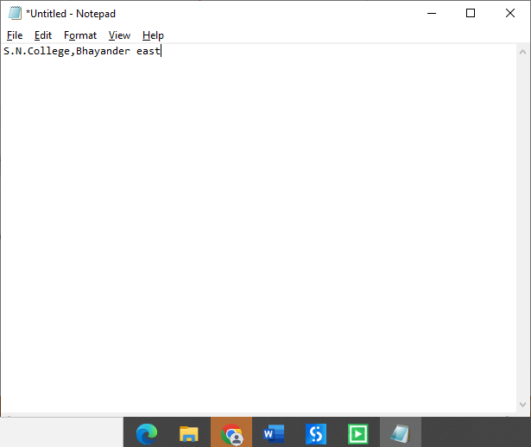

**3 e) Web Recording e.g. Find the rating of the movie from imdb web site**

Step 1: Open UI path and create new project with appropriate name and choose language type VB.

Step 2: Click on App/Web recorder. Choose chrome and click on it.

Step 3: It will open chrome. Select address bar and type any movie name with imdb rating. Press enter key.

Step 4: It will show Imdb rating of movie.

Step 5: Click on save recording.

Step 6: It will show all process like below.

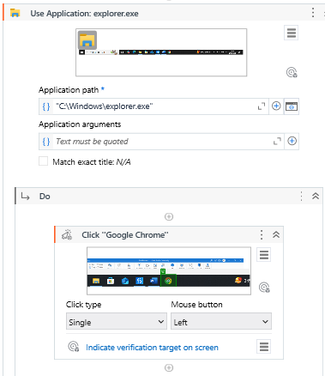

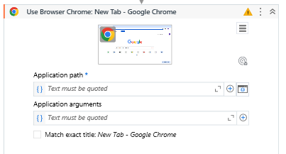

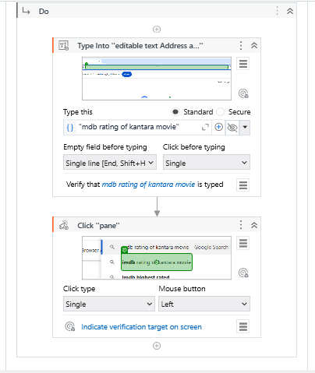

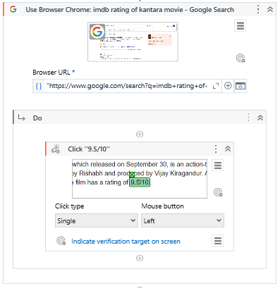

**O/P: Run your bot and check. It will show same output.**

**3 f) Automate any process using web recording**

Step 1: Open UI path and create new project with appropriate name and choose language type VB.

Step 2: Click and drag open browser from the activity panel.

Step 3: Enter Url of the form under double quotation.

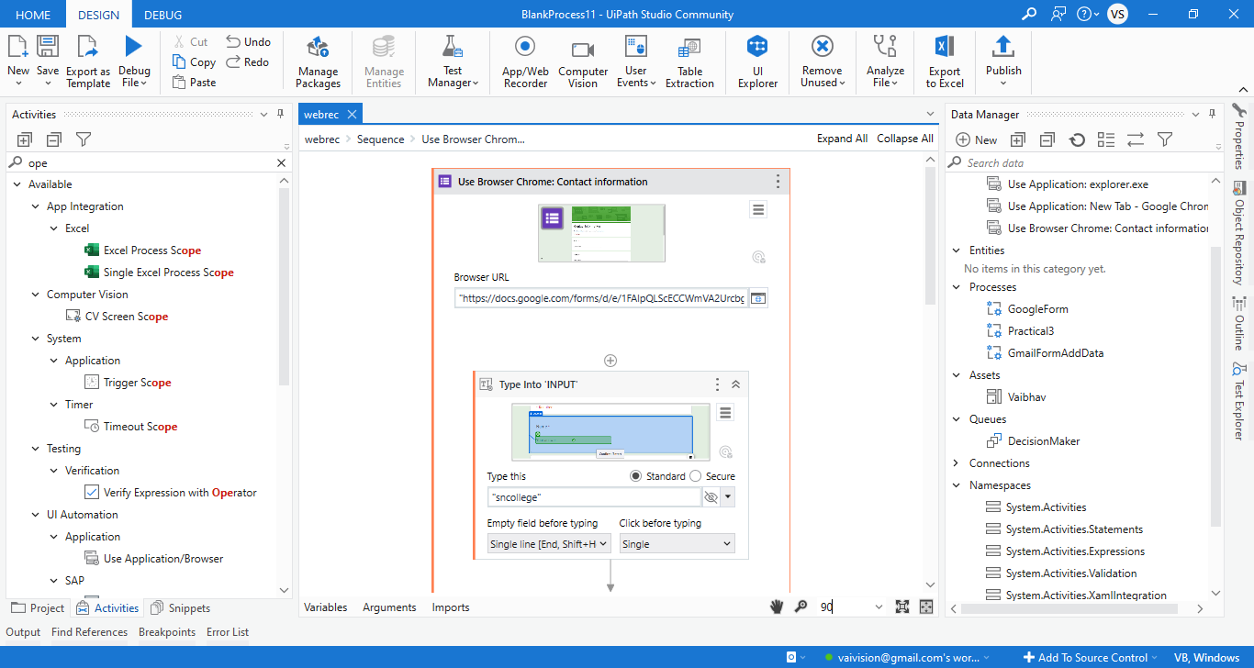

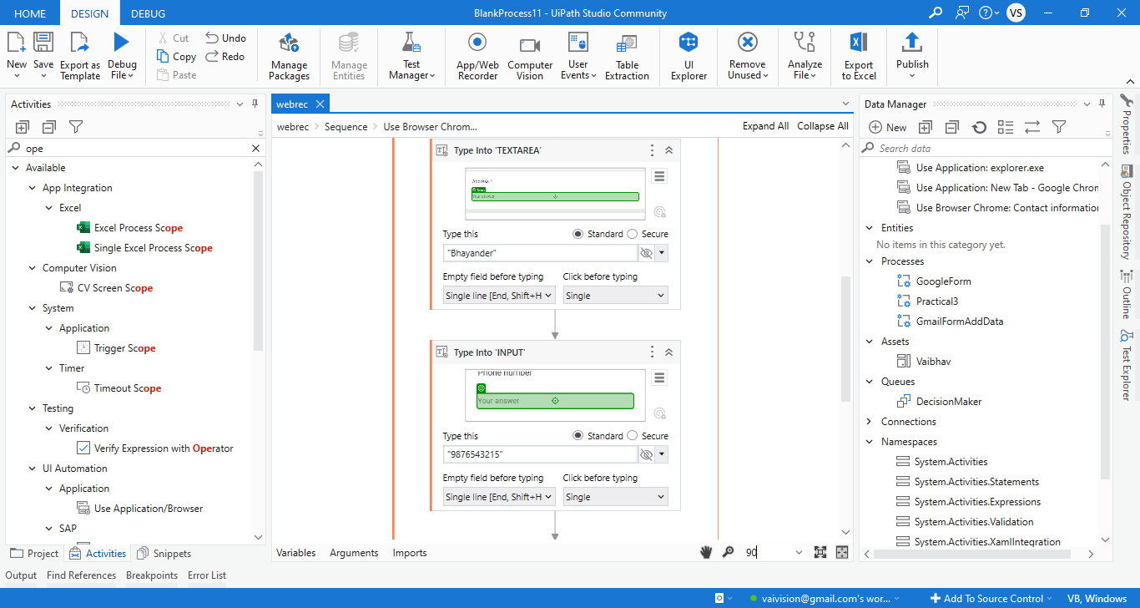

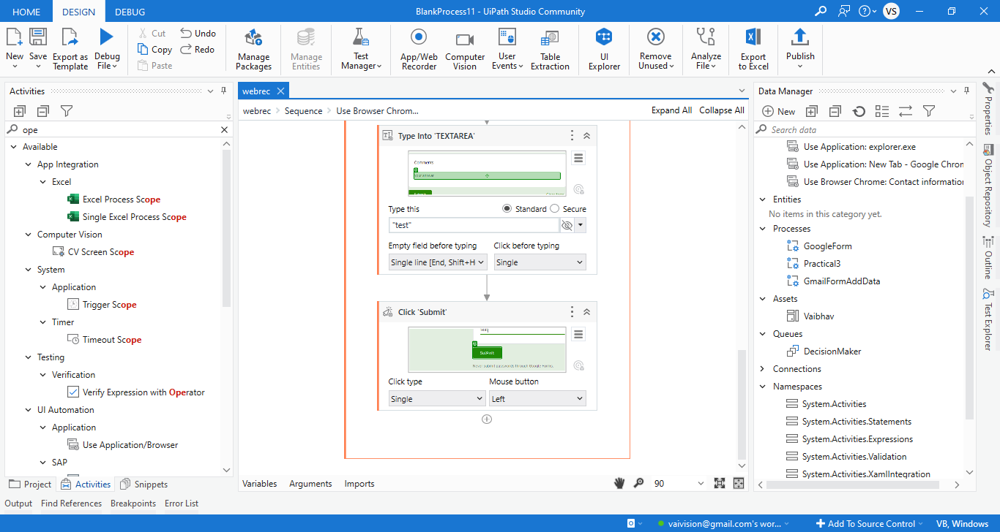

O/P:

